(Date)

County Child Health Notes
Promoting early identification and partnerships between families, primary health care providers & the community.

Distributed by: (2)
Contributors: Washington State Department of Health (DOH) and UW - Center on Human Development & Disability. Primary issue author: Shilpi Chabra, MD, Neonatologist, UW and Seattle Children’s. Issue editor and co-author: Sophie Lu, MN, ARNP, Developmental Pediatric Nurse Practitioner, UW CHDD. Reviewers: Melissa Charbonneau, RN, BSN, PHN 3, Spokane Regional Health District; Bat-Sheva Stein RN, MSN, Perinatal Nurse Consultant, WA State DOH; Tiffani Buck WHNP-BC, MS, RN, WA State DOH.
Late and Moderate Preterm Infants: Best Practices for a Population at Risk

Moderate and late preterm infants, defined as birth at 32 0/7-33 6/7 weeks and 34 0/7-36 6/7 weeks of gestation respectively, are more vulnerable to brain injury and neurodevelopmental sequelae than previously appreciated. They account for ~84% of all preterm births and ~6–7% of all births in the United States. These infants are at increased risk for short and long-term neonatal morbidity and mortality. The third trimester of pregnancy is a period of rapid fetal brain development characterized by growth of gray matter, increased myelination, increased synaptogenesis and neural connectivity. Underdevelopment of the preterm brain has been associated with poorer educational/academic performance and lower intellectual ability compared with full-term infants. The most common clinical problems for this population are respiratory distress/insufficiency in the immediate neonatal period, hypoglycemia, hyperbilirubinemia, hypothermia, and feeding difficulties.

Late preterm infants are often considered “imposters” as they appear healthy and may have similar developmental scores as their term counterparts at 24 months. However, issues with higher executive function reemerge at preschool and kindergarten. Because of these high numbers, even a modest increase in babies born at these gestations can have a high impact on the economic burden due to long- term health and developmental problems.

CDC Natality Dashboard for increasing Preterm Birth Rates
The 12 month total preterm birth rates (<37 weeks) increased from 9.87% to 9.93% (2017 Q1 to 2018 Q1). This increase was due to an increase in the late preterm (34-36 weeks) birth rates (from 7.12% to 7.18%) with no change seen for early preterm (<34 weeks) (2.75% to 2.75%).

Short Term Outcomes
Immediate Postnatal Period:
- Most common clinical problem: increased incidence of respiratory distress
  - 1/3 need respiratory support and
3% need mechanical ventilation
  - Rarely severe respiratory failure requiring ECMO
- Apnea
- Feeding immaturity
- Hyperbilirubinemia
- Hypothermia
- Hypoglycemia
- Sepsis

Newborn Period:
- Have higher morbidity & mortality than term infants. They are:
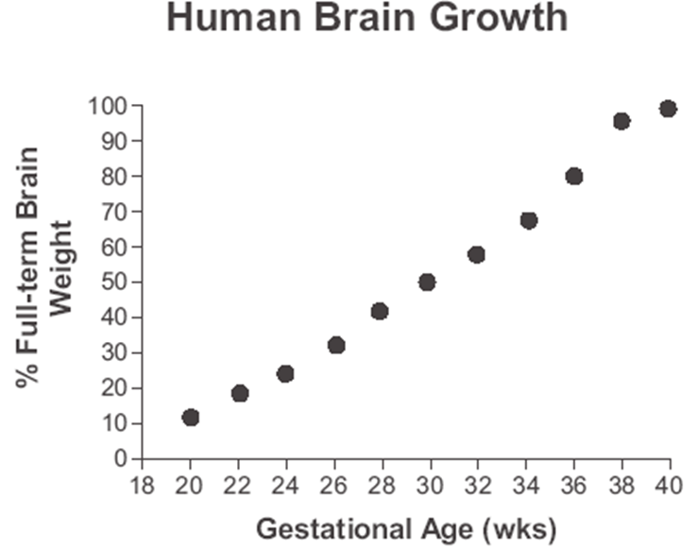
  - 1.5 times more likely to need hospital care after routine newborn care
  - 2 times more likely to be readmitted to hospital during the first 28 days of life.

Long Term Outcomes
Compared to term, higher risk for:
- Motor and language delay
- Poor executive functioning (self-regulation, inhibition, judgement, working memory)
- Poor visual-motor skills
- Lower intelligence
- Lower reading and math scores
- Difficulty with fine motor skills and writing
- Behavioral and emotional disturbances
- Psychological problems
- Blindness, decreased vision, hearing loss, epilepsy
At school age increased risk for:
- Cognitive impairments
- Difficulty with complex language functions
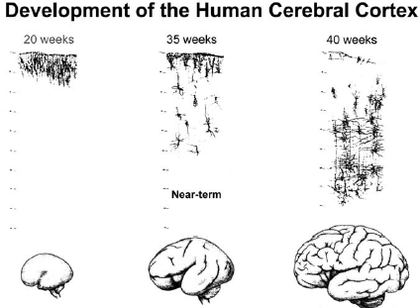
- Up to 1/3 with learning difficulties requiring additional help at school
- Hyperactivity in 8% with associated poor school performance
- Neurosensory impairments: sensory modulation and processing difficulty
- Motor skills (coordination, balance)

Implications for Primary Care Providers (PCPs)
It will be important for PCPs to remember that patients with a history of moderate-to-late preterm birth face a higher incidence of developmental delays, learning/school challenges (particularly in reading and math), executive functioning difficulties, and behavioral problems. PCPs can identify developmental delays in this population through universal developmental screenings with a standardized instrument at well-child visits. If a concern is identified, a PCP may refer for further evaluation to early intervention (if under 3 years old), to the school for an Individualized Education Plan (IEP) (if 3 years and older), and/or a neurodevelopmental specialist such as a developmental pediatrician or developmental nurse practitioner. PCPs can also have families fill out the Ages and Stages Questionnaire (ASQ) online through WithinReach free of charge for Washington State families. It takes 10-15 minutes to complete the ASQ. A coordinator from WithinReach will call the family to talk about the results and can suggest activities or resources. PCPs can partner with families in monitoring for developmental issues by educating parents on the short and long-term morbidities of this population.

References
Cheong JL, Doyle LW, Burnett AC, Lee KJ, Walsh JM, Potter CR, Treyvaud K, Thompson DK, Olsen JE, Anderson PJ, Spittle AJ. Association Between Moderate and Late Preterm Birth and Neurodevelopment and Social-Emotional Development at Age 2 Years. JAMA Pediatr. 2017 Apr 3;171(4):e164805
Johnson S, Evans TA, Draper ES, Field DJ, Manktelow BN, Marlow N, Matthews R, Petrou S, Seaton SE, Smith LK, Boyle EM. Neurodevelopmental outcomes following late and moderate prematurity: a population-based cohort study. Arch Dis Child Fetal Neonatal Ed. 2015 Jul;100(4):F301-8.
Kelly CE, Cheong JL, Gabra Fam L, Leemans A, Seal ML, Doyle LW, Anderson PJ, Spittle AJ, Thompson DK.Moderate and late preterm infants exhibit widespread brain white matter microstructure alterations at term-equivalent age relative to term-born controls. Brain Imaging Behav. 2016 Mar;10(1):41-9.
Shah PE, Kaciroti N, Richards B, Lumeng JC. Gestational Age and Kindergarten School Readiness in a National Sample of Preterm Infants. J Pediatr. 2016 Nov;178:61-67.
Spittle AJ, Walsh JM, Potter C, Mcinnes E, Olsen JE, Lee KJ, Anderson PJ, Doyle LW, Cheong JL. Neurobehaviour at term-equivalent age and neurodevelopmental outcomes at 2 years in infants born moderate-to-late preterm. Dev Med Child Neurol. 2017 Feb;59(2):207-215.

Special Needs Information and Resources:

Local: | (3)  (4)  (5)
Regional: | UW Late and Moderate Preterm Babies (LAMBs) Clinic  Specializes in the moderate and preterm population. Offers developmental evaluations from 4 months corrected age up to 2-3 years chronological age at regular intervals. | Phone: 206-598-9348  https://healthonline.washington.edu/document/health_online/pdf/LAMBs-Clinic.pdf (if link doesn’t open, copy and paste in browser)
Regional: | Early Support for Infants and Toddlers Program | https://www.dcyf.wa.gov/services/child-development-supports/esit  Phone number: 360-725-3500
Regional: | Ask Now - Babies & Kids Can't Wait brochure (Providers can order from WithinReach Website) | http://www.withinreachwa.org/products-page/
Regional: | Snohomish County’s EI Website has fantastic resources including: Kindergarten Readiness Guidelines | https://snohomishcountywa.gov/607/Early-Intervention-Program-Birth-to-Thre
Regional: | School Readiness information from WithinReach Website for families | http://parenthelp123.org/pages/child-development/4-6/school-readiness/preview
National/  Internet: | Multidisciplinary Guidelines for the Care of Late Preterm Infants by the National Perinatal Association | http://www.nationalperinatal.org/latepreterm
 | Late Preterm Birth: Late Preterm Preterm Birth:  Increased Clinical Risk Presentation by Dr. Jodi Jackson | https://www.marchofdimes.org/chapterassets/files/late_preterm_birth__jodi_jackson_revised.pdf (if link doesn’t open, copy and paste in browser)
 | Supporting Premature Infant Nutrition (SPIN) at UC San Diego Health, Late Preterm Infant Information | https://health.ucsd.edu/specialties/obgyn/maternity/newborn/nicu/spin/staff/Pages/late-preterm.aspx
 | Policy Statement from the American Academy of Pediatrics: The Pediatrician’s Role in Optimizing School Readiness | http://pediatrics.aappublications.org/content/138/3/e20162293  Pediatrics, Sept 2016, Volume 138 / Issue 3

