A menu of resources to support individuals with intellectual and developmental disabilities (IDD)

~~~ Financial ~~~
Prescription for Diapers | What is it? For children ages 3 years and older, diapers can be covered by medical insurance with a prescription.  How to get it: You will need an annual prescription for diapers with a diagnostic code of bowel and bladder incontinence from your medical provider. A medical supply company will provide you with the diapers.
Charity Care and Financial Assistance at Washington State Hospitals | What is it? Washington’s hospitals want patients to get the hospital care they need regardless of their ability to pay for that care. Charity care eligibility is based on family size and income. Providing health care to those that cannot afford to pay is part of the mission of Washington’s hospitals. State law requires hospitals to provide free and discounted inpatient and outpatient care. Each hospital is responsible for its own charity care program.  How to get it: Reach out to the hospital’s charity care/financial assistance program for information on eligibility and to get the application. Below are links to information on the children’s hospital programs:  Seattle Children’s Hospital  https://www.seattlechildrens.org/clinics/paying-for-care/financial-assistance/  Sacred Heart Hospital  https://www.hshs.org/SacredHeart/Patients-Guests/Patient-Financial-Services/Patient-Financial-Assistance  Mary Bridge Children’s (part of Multicare)  https://www.multicare.org/patient-resources/financial-assistance/
Supplemental Security Income (SSI) | What is it? Supplemental Security Income (SSI) is a federal program that gives payments to children and adults with disabilities who have limited income and resources. The cash payments can be used to meet basic needs for food, clothing, and shelter.  How to get it: Call toll-free at 1-800-772-1213 (TTY 1-800-325-0778) between 8:00 am – 7:00 pm., Monday through Friday.
Developmental Disabilities Administration (DDA) | What is it? The Developmental Disabilities Administration (DDA) is where people go to get help for in-home, out-of-home, and community-based services. Children who do not qualify for SSI due to family income may still be eligible for DDA services which are based on the child’s disability and not family income.  How to get it: Website on how to apply: https://informingfamilies.org/topic/dda-services/  Website where you apply: https://www.dshs.wa.gov/dda
Medicaid Premium Payment Program | What is it? If your child has private health insurance coverage (such as through your employer) and also has Medicaid (Apple Health), Medicaid can reimburse you for the private health insurance coverage.  How to get it: https://www.hca.wa.gov/health-care-services-supports/program-administration/premium-payment-program
Ben’s Fund  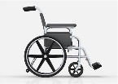 | What is it? This is only for children who have a diagnosis of Autism Spectrum Disorder. It is a $1000 grant that can be used for your child’s services, therapies, camps, equipment, safety/security, technology, etc.  How to get it: www.bensfund.org
UHCCF Medical Grant | What is it? United Healthcare Children's Foundation (UHCCF) runs a grant program for children ages 16 years and younger who have private insurance. The grant funds can be used to support medical care costs not covered by insurance.  How to get it: https://www.uhccf.org/
NeedyMeds - List of Grants | What is it? Diagnosis-Based Assistance Programs - this site has a list of diagnoses and different grant programs that are available to support individuals with those diagnoses.  How to get it: https://www.needymeds.org/copay-diseases

~~~ Transportation ~~~
Disability Parking Placard  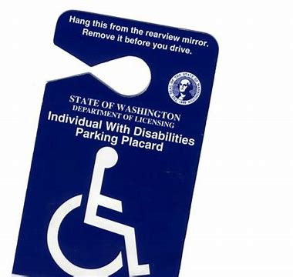 | What is it? A parking placard (sign) that allows your family to park close to the entrance of medical/dental offices, hospitals, grocery stores, shopping centers, zoos, etc. if your family needs this support and your child has a qualifying medical condition.  How to get it: Talk to your child’s medical provider to see if they would qualify (many children with autism qualify under the “ability to walk is severely limited due to a neurological condition.”) If they do qualify, your child’s medical provider needs 1) to write a prescription, and 2) complete their section of the Disabled Parking Application for Individuals. Take both of these to where you get your parking tabs. More information and the Disabled Parking Application for Individuals (in multiple languages) can be found at this website:  https://www.dol.wa.gov/driver-licenses-and-permits/get-or-renew-disabled-parking-permits
Medicaid (Apple Health)  Transportation Services | What is it? The Health Care Authority (HCA) covers nonemergency transportation for eligible clients to and from covered medical appointments. The HCA does this through “transportation brokers” (organizations that manage this service). To be eligible, clients must have a current ProviderOne services card, have no other way to reach your health care appointment, and must ensure that the appointment is covered by your Apple Health program. The most common types of transportation available include: public bus, taxi, wheelchair van, airplane, gas vouchers, ferry tickets, and reimbursement for vehicle mileage.  How to get it: Contact the transportation broker for your county. The transportation broker will arrange transportation that is most appropriate for you. Transportation to health care providers that are outside of your local community will need approval from the transportation broker.  https://www.hca.wa.gov/health-care-services-supports/apple-health-medicaid-coverage/transportation-services-non-emergency#transportation-broker-directory
WA State Ferries  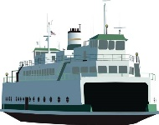 | What is it? Reduced fare tickets on WA State ferries.  How to get it: Present identification verifying disability eligibility to the ticket seller when purchasing a ticket.  Discounted Fare Information: https://wsdot.wa.gov/travel/washington-state-ferries/rider-information/riders-disabilities/disability-discounted-fare
Public Transportation  Reduced Fare Permit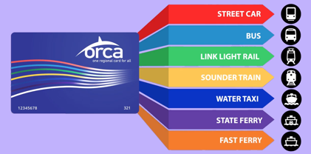 | What is it? People with disabilities may ride the bus or train at a reduced rate if they submit an application to their local agency and get approved for a permit.  How to get it: Contact your local public transportation office for information on eligibility and the application.  Orca Card/Sound Transit: https://www.soundtransit.org/ride-with-us/how-to-pay/fares/regional-reduced-fare-permit  Spokane: https://www.spokanetransit.com/files/content/rf-passapplication-final.pdf (includes application) Autism specifically called out  Yakima: https://yakimatransit.org/media/DAR-Reduced-Fare.pdf

~~~ Recreation ~~~
National Parks  Pass | What is it? The Access Pass is a free, lifetime pass available to U.S. citizens or permanent residents of the United States that have been medically determined to have a permanent disability that severely limits one or more major life activities. It provides access to more than 2,000 recreation sites managed by five Federal agencies.  How to get it: You can get the pass in person at a federal recreation site or through the mail. While the pass itself is free, there is $10 for application processing fee if you of get it through the mail or online.  Information on Access Pass (including the list of federal recreation sites) https://www.nps.gov/subjects/accessibility/interagency-access-pass.htm  Website to purchase Access Pass online  https://store.usgs.gov/access-pass
WA State Parks -Discover Pass | What is it? You do NOT need a Discover Pass for day use access at state parks if you have a disability placard/license plate OR a free state-issued Disability Pass. This program also offers free watercraft launching, trailer dumping and a 50% discount on camping and moorage.  How to get it:  https://www.parks.wa.gov/1207/Disability-Pass  https://www.discoverpass.wa.gov/131/Exemptions

~~~ Technology ~~~
Telecommunication Equipment Distribution (TED) program  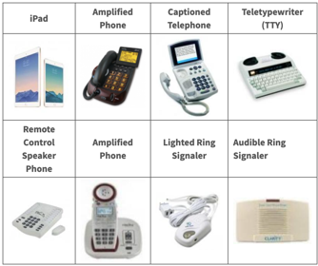 | What is it? The TED program provides equipment that can be used for communication such as captioned phones, teletypewriters, iPad Air/iPad Mini, iPhones, and anything an individual needs to access the equipment (e.g., switches, mounts, and speech generating apps). Anyone who lives in WA State (over age 4 years) and who is deaf, hard of hearing, deaf-blind, or has difficulty with speech (including autism, Cerebral Palsy, etc.) is eligible for help from the TED program. Equipment may be a reduced cost or free of charge depending on income level.  How to get it: https://informingfamilies.org/wp-content/uploads/2020/04/TED.pdf  Website with application: https://www.dshs.wa.gov/altsa/odhh/telecommunication-equipment-distribution

This resource list was created by Shayla Collins in collaboration with Sophie Lu, ARNP and with contributions from other staff of the University of Washington Leadership Education in Neurodevelopmental and Related Disabilities (UW LEND), the WA INCLUDE Collaborative, the Seattle Children’s Autism Center, and community partners. It is distributed through the Washington State Medical Home Partnerships Project (MHPP) and can be found at https://medicalhome.org/quick-key-resources/shaylas-list-family-support/

If you would like to share ideas or feedback on this list, please send an email to info@medicalhome.org.

