Families with children 0-3 years old, discharging from the NICU, MED, and SURG floors will get a discharge packet to help answer common questions.
Parent Packet Contents:
- Who to Contact about my Child’s Feeding Plan
  - Description: A guide for families to address their nutrition and feeding questions.
  - Website: Child- NICU Toolkit
  - Available in: English

- A Family’s Guide to Early Intervention Services in Washington State (FS_0002)
  - Description: Provides families with an in-depth description of early intervention services and their rights.
  - Print/order from: Forms & Publications | Washington State Department of Children, Youth, and Families
  - Ordering: If unable to order through website, email Saalfeld, Ciara (DCYF) ciara.saalfeld@dcyf.wa.gov
  - Available in multiple languages

- Support Resources for Families of Children with Special Needs
  - Description: Mental, social, and physical support resources for families.
  - Website: On Child- Go to Family Resource Center Toolkit
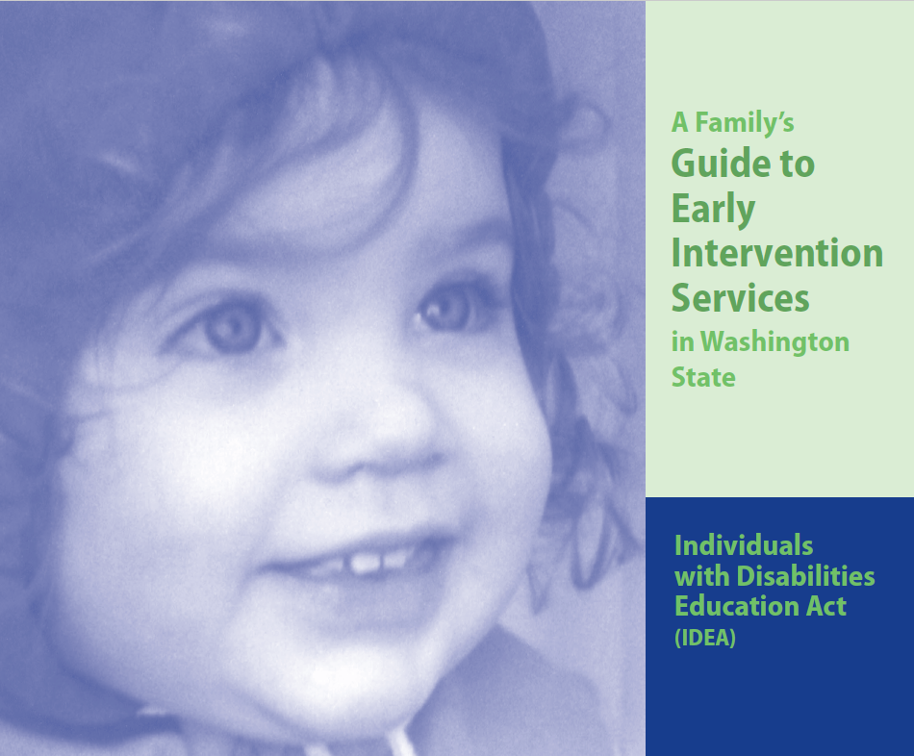
  - Available in multiple languages
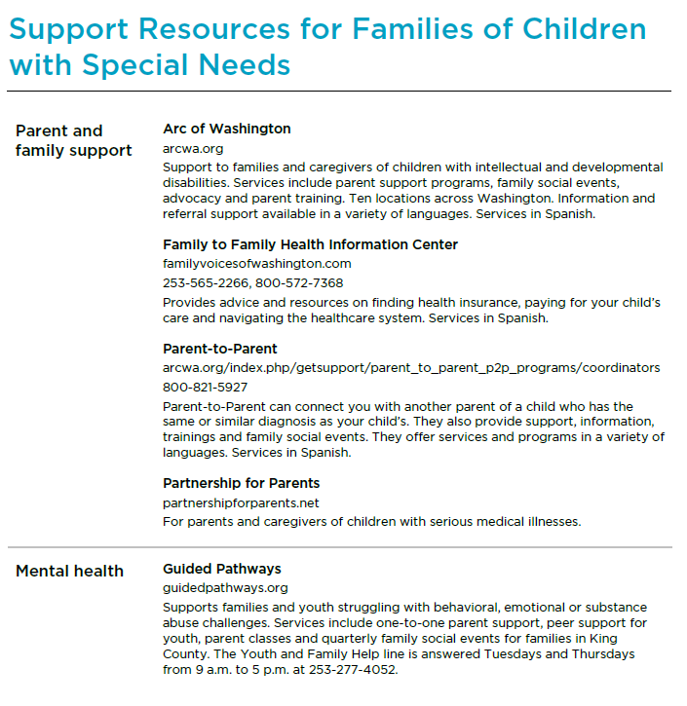
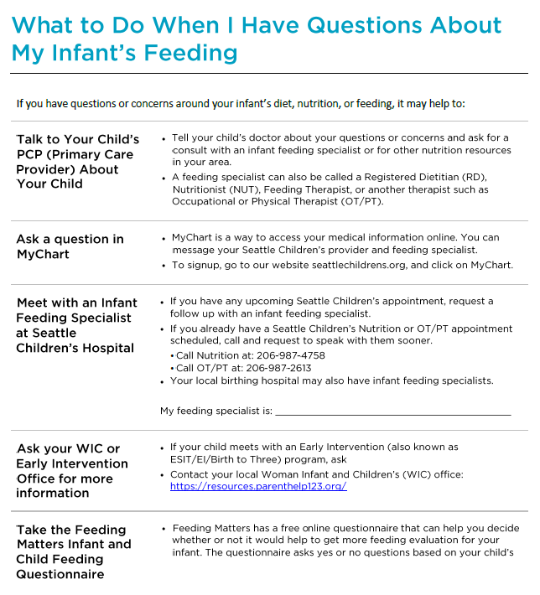

Additional Materials on Demand:
- Milestones
  - Description: Guide for families of developmental milestones.
  - Ordering/Printing website: Get Free “Learn the Signs. Act Early.” Materials | CDC
  - Available in multiple languages.
- Developmental Disabilities Administration (DDA)
  - Description: Resources explaining what DDA is, qualifying, and services.
  - Website/Ordering: DDA Brochures | DSHS (wa.gov)
  - Roadmap to Services
    - Available in multiple languages.
  - A Guide to Eligibility, Supports and Services
    - Available in multiple languages.
- Supplemental Security Income (SSI): Benefits for Children With Disabilities
  - Description: Government program that provides extra income for children with a disability. Documents updated yearly.
  - Website: https://www.ssa.gov/benefits/ssi/
    - Factsheet and Child Starter Kit available at:
    - Child Disability Starter Kit (ssa.gov)
  - PDF: Under link “Children with a disability”. To print other language use: https://www.ssa.gov/site/languages/en/
  - Available in multiple languages.
- Regional Clinics
  - Description: Links for detailed PDFs of the providers, phone numbers, and all services provided at specific clinics. Clinics listed are: North Clinic, Bellevue, Olympia, South Clinic, Tri Cities, Wenatchee
  - Website: Regional Clinics (seattlechildrens.org)
  - Available in English
- Emergency or Urgent Care?
  - Description: Explains the difference between urgent care and emergency room.
  - Website: Bottom of page has PDF versions of information. https://www.seattlechildrens.org/clinics/urgent-care-clinic/emergency-or-urgent-care/
  - Available in multiple languages.
- Medicaid Transportation and Lodging Services for Medicaid-approved families in Washington
  - Description: guides families to agencies for transportation, lodging, or reimbursement.
  - Website: https://www.seattlechildrens.org/pdf/PE539.pdf
  - Available in multiple languages.
- UW CHDD- Infant Development Follow-Up Clinic
  - Description: UW Clinic for high risk infants with health/developmental needs.
  - Website: https://depts.washington.edu/chdd/families.html
  - Parking Brochure: Parking information for patients of the CHDD specialty care clinics (washington.edu)
  - Overview of Clinic Brochure: https://depts.washington.edu/dbpeds/Clinics%20and%20Activities/IDFC%20Brochure.pdf
  - Available in English
- Crying Purple
  - Description: Guide to understand infant crying and how to respond.
  - Website: On Unit Coordinator Toolkit
    - https://www.seattlechildrens.org/pdf/PE1874.pdf
  - Available in multiple languages.

Additional Resources
See Related Job Aid/FAQ/Policy (Edit or Delete this line, based on presence of additional documents)

For questions about this job aid, contact: UC Leadership Team via the UC Inbox Unitcoordinatorinbox@seattlechildrens.org

