(Date)

(1) County Child Health Notes
Promoting early identification and partnerships between families, primary health care providers & the community.

Distributed by: (2)
Contributors: the University of Washington, Center on Human Development & Disability (CHDD) & the Washington State Department of Health (DOH). Issue editor: Sophie Lu, MN, ARNP, Developmental Pediatric Nurse Practitioner, UW CHDD. Content adapted from presentation by Michelle Kuhn, PhD, Post-Doctoral Fellow, Psychiatry and Behavioral Medicine with Dr. Kuhn participating as a content expert reviewer.
How to Ask About Prenatal Alcohol Exposure
“Of all the substances of abuse, including cocaine, heroin, and marijuana, alcohol produces by far the most serious neurobehavioral effects in the fetus.” – Institute of Medicine, 1996.
According to a 2011 Report of the National Task Force on Fetal Alcohol Syndrome and Fetal Alcohol Effect, prenatal alcohol exposure (PAE) is the most common preventable cause of developmental and intellectual delay and disabilities in the United States.‍ Fetal Alcohol Spectrum Disorders (FASD) is an umbrella term for diagnoses describing the effects of prenatal alcohol exposure (PAE) with a prevalence estimated to be 2-5%. It is certain that all primary care providers (PCP) see patients with PAE in their practices.

Notably, 80% of children with PAE and FASDs do not have identifiable physical features. This makes gathering information about PAE when taking a history of utmost importance. However, many providers feel uncomfortable with asking—these are some reasons for the discomfort:
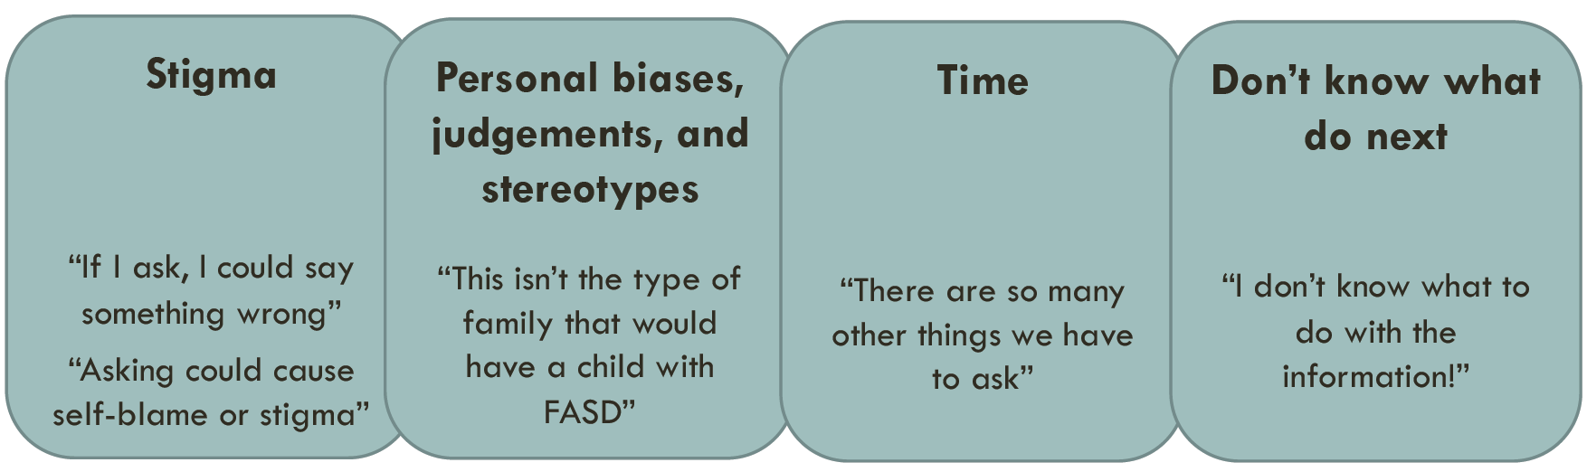
Some providers may also believe that if there is a positive history of PAE, it must be reported to Child Protective Services (CPS). Exposure to alcohol during pregnancy is not considered abuse or neglect. Child Abuse Prevention and Treatment Act (CAPTA) laws for developing a plan of safe care do apply to infants who have been identified as being affected by substance abuse or withdrawal symptoms or who are diagnosed with an FASD as an infant.
Why PAE Occurs

- Lack of knowledge: 30% of women and 50% of men believe daily alcohol consumption is safe during pregnancy
- Community and partner norms: PAE is 34 times more likely with risky paternal drinking
- Not aware of pregnancy: 50% of pregnancies are unplanned
- Alcohol use disorders: though this is not the only cause of FASDs

Not Asking Because of Stigma Results in 2 Missed Opportunities
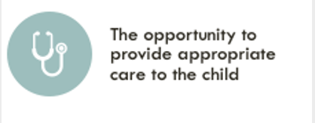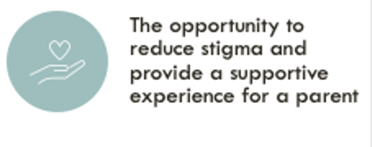

Creating a Supportive, Non-Judgmental Environment
- Ground yourself in your purpose.
Knowing about prenatal exposures can help us better understand, support, and know what to look for developmentally in children dealing with behavior problems.
- Cultivate a mindful stance and open heart.
Take note of any experiences, thoughts, and biases you might have about alcohol use.
- Be “matter of fact.”
Be aware of nonverbal communication that might communicate your opinion about ‘correct’ answers.

Asking About PAE
When to Ask
- Ask at all new (to you) patient visits within the context of asking about general health including during pregnancy as a part of the history and intake.
How to Ask the Person Who Gave Birth to the Child
- Before gathering information on pregnancy, acknowledge that unexpected illnesses, events, and exposures are very common.
  - “Now I am going to ask you some questions about your pregnancy with CHILD. We know that every pregnancy is different (and often full of surprises!) so I’ll ask about some of the most common experiences. Just let me know if I missed one that was important for your pregnancy with CHILD.”
- Consider talking to the person who gave birth to the child by themselves, instead of with their partner.
  - “We’ve learned that the best way to learn about pregnancy is to talk to the person who gave birth. COPARENT can you fill out XYZ questionnaire and we will call you back in in a moment?”
- Start with general topics (i.e., prenatal care, general health), then move to exposures (i.e., stress, medication, teratogens, etc.)
- Sample prompts from the PAE Clinician Toolkit by Families Moving Forward:
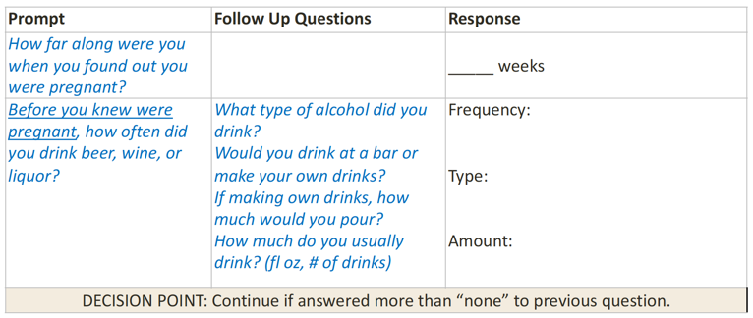
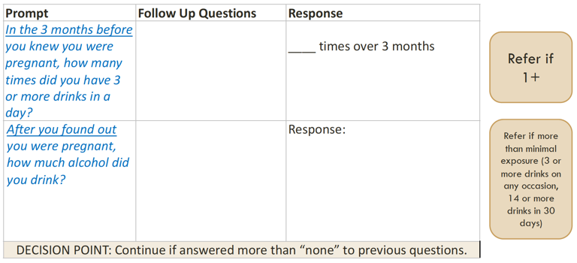

What Information is Needed
- Was there any PAE?
- Was there relatively higher-risk PAE?
  - Any binge episodes? (≥3 drinks on one occasion)
  - Periods of consistent exposure? (Even if at a lower dose, such as one standard drink on a daily or every other day basis for several weeks.)

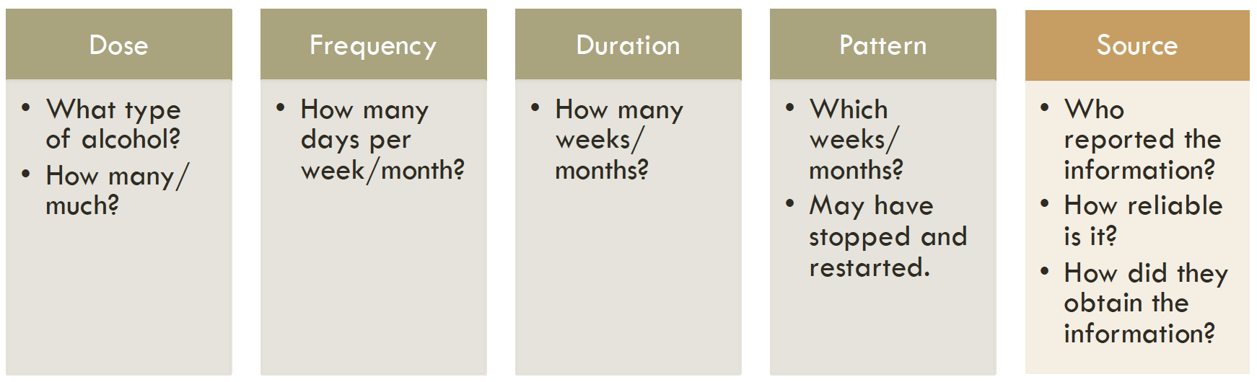

Documentation Considerations for PAE
Source and reliability:
- CAREGIVER indicated that there was not prenatal exposure to alcohol.
- CAREGIVER does not have access to information regarding pregnancy or birth.
- CAREGIVER indicated that there was confirmed/suspected prenatal exposure to alcohol, as reported by/recorded in SOURCE.
Dose/frequency/duration/pattern:
- (Consistent use) There was exposure to between # and # standard drinks # of times per WEEK/MONTH over the TRIMESTER/WEEK RANGE. <repeat if use resumed>
- (Episodic) There was exposure to approximately # standard drinks during one drinking occasion during the # week of pregnancy.

How Does Asking Help?

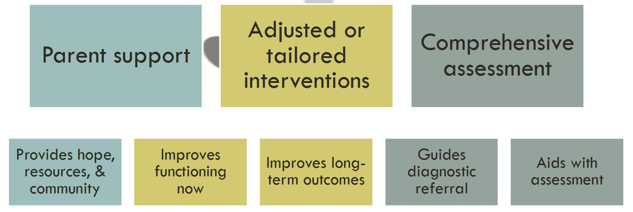

Special Needs Information and Resources
Local: | (3)  (4)  (5)  (6)
Regional: | Families Moving Forward Program for FASD  PAE Clinician Toolkit | http://familiesmovingforwardprogram.org/  https://familiesmovingforwardprogram.org/?page_id=2518
 | The National Organization on Fetal Alcohol Syndrome (NOFAS) WA State | https://www.nofaswa.org/
 | FASD Diagnostic & Prevention Network (DPN) | https://depts.washington.edu/fasdpn/htmls/4-digit-code.htm
 | Specialized Neurodevelopmental Assessment and Consultation Service (SNACS) at Seattle Children’s Autism Center | https://www.seattlechildrens.org/globalassets/documents/for-patients-and-families/pfe/pe2300.pdf
 | WithinReach Help Me Grow Washington Hotline | 1-800-322-2588, 1-800-833-6388 TTD  http://www.parenthelp123.org/  Spanish: http://www.parenthelp123.org/es/
National: | Pediatrics – American Academy of Pediatrics (AAP) Journal | The Role of Integrated Care in a Medical Home for Patients With a Fetal Alcohol Spectrum Disorder
 | AAP FASD Webinar Series | https://www.aap.org/en-us/advocacy-and-policy/aap-health-initiatives/fetal-alcohol-spectrum-disorders-toolkit/Pages/Upcoming-Webinars.aspx
 | AAP FASD Toolkit | https://www.aap.org/en-us/advocacy-and-policy/aap-health-initiatives/fetal-alcohol-spectrum-disorders-toolkit/Pages/default.aspx
 | CDC Fetal Alcohol Spectrum Disorders (FASD) Training and Resources | https://nccd.cdc.gov/FASD/
 | CDC Basics about FASDs | https://www.cdc.gov/ncbddd/fasd/facts.html
 | Substance Abuse and Mental Health Services Administration (SAMHSA) Find Treatment website | https://www.findtreatment.gov/

