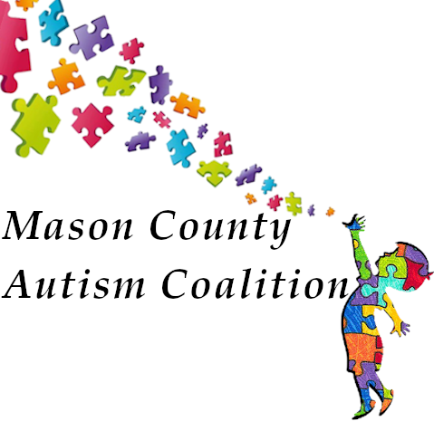
Dear Parent or Guardian,

Your child has been referred to the School Medical Autism Review Team due to concerns of possible Autism Spectrum Disorder (ASD). Enclosed is a packet of information and forms that are needed to further address this issue. Please read this material and follow all instructions so we can be of outmost help to you and your child.

Patients needing a first evaluation for possible ASD will need the following:
Our ASD screening process consists of gathering all relevant information concerning your child’s medical, academic, family, and social history.

- Parents/caregivers, please complete and return to our office the following forms (enclosed)
  - Authorization of Release of Records
  - SMART demographics form
  - SMART tool

- Give a SMART tool to anyone familiar with your child such as current teacher, SLP, OT and/or Daycare provider.
  - It is your responsibility to ensure the school /providers return these forms to you prior to submitting the package for the SMART to review.

- Provide our office with copies ( no originals please) of:
  - Report cards –past 2 years
  - Reports of any testing done by school psychologist, occupational, language or physical therapists, child find, developmental screening or school district required testing.
  - Copies of 504 plan, IFSP or IEPs if applicable
  - Reports of any previous evaluations by physicians, psychologists or psychiatrists.
Ask the school for copies of needed

Please bring the completed packet to Pediatric Department c/o Mason Clinic 1701 N 13th street Shelton WA 98584; or fax: 888-985-0681 Upon receipt of info, our team will assess the data

