(Date)

(1) County Child Health Notes
Promoting early identification and partnerships between families, primary health care providers & the community.

Distributed by: (2)
Contributors: the University of Washington, Center on Human Development & Disability (CHDD) & the Washington State Department of Health (DOH). Issue author & editor: Sophie Lu, MN, ARNP, Developmental Pediatric Nurse Practitioner, UW CHDD. Reviewers: Emily Myers, MD, Clinical Associate Professor of Pediatrics, University of Washington School of Medicine. Ashley Yerxa RN, BSN, Public Health Nurse, Adams County Health Department.
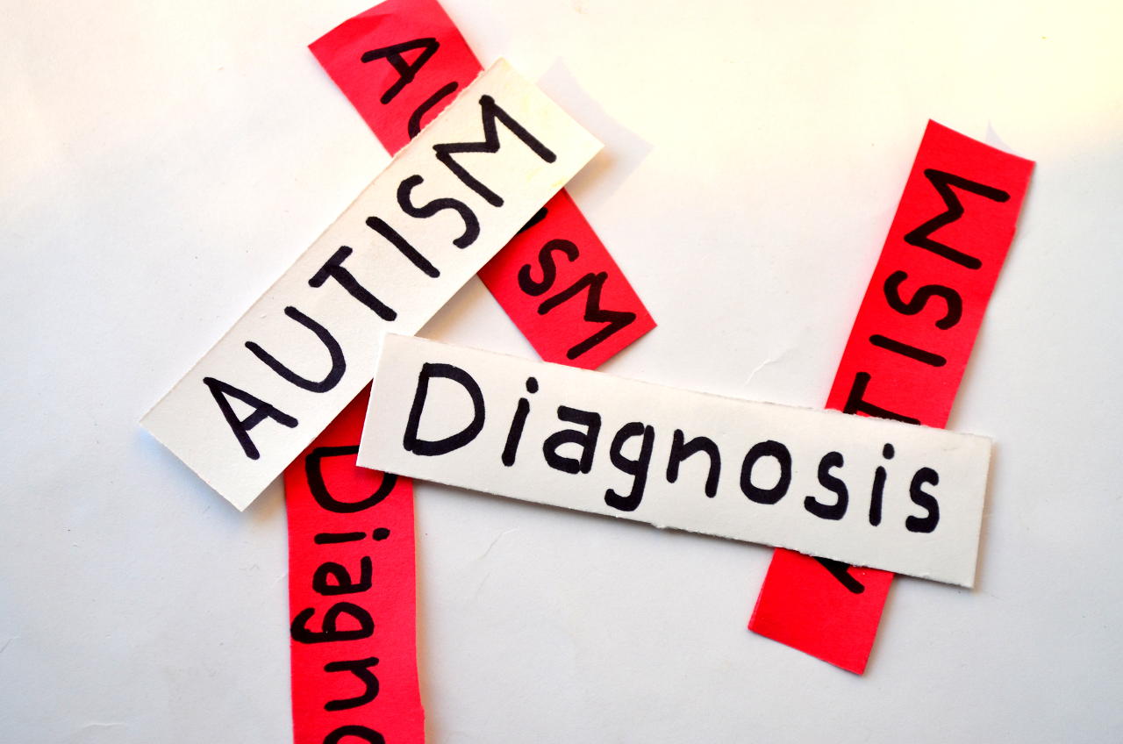
Autism Spectrum Disorder – An Overview

Autism spectrum disorder (ASD) is a brain-based disorder characterized by social-communication challenges, and restricted and repetitive behaviors, activities, and interests. In the most recent data from 2018 from the Centers for Disease Control’s (CDC) Autism and Developmental Disabilities Monitoring (ADDM) Network, it is estimated that 1 in 59 children has been identified with ASD. Ten years prior (in 2008), the prevalence of ASD was estimated at 1 in 88 by the CDC ADDM Network.

ASD is diagnosed more than 4 times as frequently in boys than in girls, and occurs across all racial, ethnic, and socioeconomic groups. More white children are identified with ASD than black and Latinx children. Some barriers to identification have been cited as lack of access to healthcare due to lower socioeconomic status or citizenship status, language, and stigma. Although prevalence ratios comparing different racial and ethnic groups were lower in the most recent ADDM report than in previous reports, black and Latinx children still continue to be screened and referred to services less frequently than white children.

Despite the growing prevalence of ASD, fewer than half of children with ASD receive their first developmental evaluation by 3 years of age and, subsequently, more than half receive a diagnosis after 4 years of age. Primary care providers (PCP) are uniquely positioned to screen and help identify children with ASD. The American Academy of Pediatrics (AAP) recently published a new clinical care guideline “Identification, Evaluation, and Management of Children With Autism Spectrum Disorder” in January 2020. There is also a complementary online course by the AAP entitled “Identifying and Caring for Children with Autism Spectrum Disorder: A Course for Pediatric Clinicians” which will is offered at no cost until 4/19/2023. Participants can earn up to 6.5 AMA PRA Category 1 Credits, 6.50 NAPNAP contact hours, and 6 MOC Part 2 credits for free.

DSM-V ASD Criteria
Deficits in social communication and interaction  (all 3 required) | Restricted, repetitive behavior or interests  (2/4 required)
- Deficits in social-emotional reciprocity  - Deficits in nonverbal communicative behavior  - Deficits in developing and maintaining relationships | - Repetitive speech, movements, or use of objects  - Excessive adherence to routines  - Fixated interests  - Hyper- or hypo- reactivity to sensory input
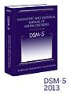
Additional DSM-V Requirements:
- Symptoms present in early development.
- Symptoms cause clinically significant impairment in functioning.
  - Level 3: requiring very substantial support
  - Level 2: requiring substantial support
  - Level 1: requiring support
- Disturbances are not better explained by a diagnosis of intellectual disability or global developmental delay

It all begins with surveillance and screening
The AAP recommends that developmental surveillance be conducted at every well-child visit. Developmental screenings should be administered whenever there is a developmental concern (e.g. parent/teacher/clinician concern, child showing unusual behaviors consistent with ASD, delays in social-emotional milestones, etc.). They should also be administered at the time intervals captured in the table below.

AAP Recommendations  For Developmental/  Behavioral Screening (AAP 2014)   | 9 months  General Developmental Screening | 18 months  General Developmental Screening  &  ASD-Specific Screening | 24 months  ASD-Specific Screening | 30 months  General Developmental Screening | 3-5 years  General Developmental Screening  &  ASD-Specific Screening as needed

Developmental screening with a standardized tool is more effective than surveillance alone
 | Without screening | With screening
Developmental delays | 30% identified | 70-89% identified
Mental health problems | 20% identified | 80-90% identified

Places to find surveillance and screening tools:
AAP Developmental Screening
CDC Developmental Monitoring and Screening for Health Professionals

Considerations for Busy Practices and Diverse Families
- Many general developmental and autism specific screens only take 5-10 minute to administer.
- Most screens are parent questionnaires and written at a 5th grade level or below.
- Some screens are available in Spanish and other languages.
- Some parents may need help answering questions—consider creating a protocol for oral administration for families with low literacy.
- Reimbursement for screening can be received by using CPT code 96110.

When to Refer
- Refer if there is a positive screen or clinical concern.
- Refer immediately to early intervention services if child is under 3 years old, or to special education if child is 3 years and older. Do not delay these referrals. An ASD diagnosis is not required to receive these services.
- Refer for audiology evaluation.
- Refer to ASD specialist which may include a Centers of Excellence (COE) in autism, clinical psychologist, or developmental specialty diagnostic center such as the UW Center on Human Development and Disability, Seattle Children’s Autism Center, the UW Autism Center, Providence Boyden Family Autism Center, or the Mary Bridge Developmental Behavioral Pediatrics department.
- Consider referral for other rehabilitative treatment such as occupational therapy or speech therapy.
- Directly refer to program if possible as referrals are more likely to be completed if you have the program reach out to the family.

Special Needs Information and Resources
Local: | (3)  (4)  (5)  (6)
Regional: | Seattle Children’s Autism Center  Patient and Family Resources | https://www.seattlechildrens.org/clinics/autism-center/patient-family-resources/
Regional: | UW Readi Lab Practical Tips and Information for Providers & Families | https://uwreadilab.com/practical-tips/
Regional: | UW Autism Center Resources Webpage | https://depts.washington.edu/uwautism/resources/
 | Northwest Autism Center: Accessing ABA Services – A Module for Providers | https://www.nwautism.org/index.php/accessing-aba-services-a-course-for-providers/
 | Help Me Grow Washington Hotline – a program of WithinReach | 1-800-322-2588, 1-800-833-6388 TTD  http://www.parenthelp123.org/ Spanish: http://www.parenthelp123.org/es/
National: | Centers for Disease Control (CDC) ASD page | https://www.cdc.gov/ncbddd/autism/index.html
 | Ohio Center for Autism and Low Incidence (OCALI) – Autism Internet Modules | https://autisminternetmodules.org/
 | Autism Speaks | https://www.autismspeaks.org/
 | University of North Carolina Supporting Individuals with Autism through Uncertain Times | https://afirm.fpg.unc.edu/supporting-individuals-autism-through-uncertain-times

References

American Academy of Pediatrics (AAP). Identifying and Caring for Children with Autism Spectrum Disorder: A Course for Pediatric Clinicians [Asynchronous Online Course]. AAP. https://shop.aap.org/identifying-and-caring-for-children-with-autism-spectrum-disorder-a-course-for-pediatric-clinicians/

Centers for Disease Control (CDC). Autism prevalence slightly higher in CDC’s ADDM Network.
https://www.cdc.gov/media/releases/2018/p0426-autism-prevalence.html

Centers for Disease Control (CDC). Data & Statistics on Autism Spectrum Disorder. https://www.cdc.gov/ncbddd/autism/data.html

Centers for Disease Control (CDC). Spotlight On: Racial and Ethnic Differences in Children Identified with Autism Spectrum Disorder (ASD). https://www.cdc.gov/ncbddd/autism/addm-community-report/differences-in-children.html

Hyman, S. L., Levy, S. E., & Myers, S. M. (2020). Identification, Evaluation, and Management of Children With Autism Spectrum Disorder. Pediatrics, 145(1), 1–64. https://doi.org/10.1542/peds.2019-3447

