(Date)

County Child Health Notes
Promoting early identification and partnerships between families, primary health care providers & the community.

Distributed by: (2)
Contributors include the University of Washington, Center on Human Development & Disability (CHDD) & the Washington State Department of Health (DOH). Issue author: Sophie Lu, MN, ARNP, Developmental Pediatric Nurse Practitioner, UW CHDD. Reviewers: Bat-Sheva Stein RN, MSN, Perinatal Nurse Consultant, WA State DOH; Tiffani Buck WHNP-BC, MS, RN, WA State DOH; Shelley Little RN, BSN, CCM, Benton-Franklin Health District; Karina Mazur, RN, BSN, IBCLC, Kitsap Public Health.
Neonatal Abstinence Syndrome
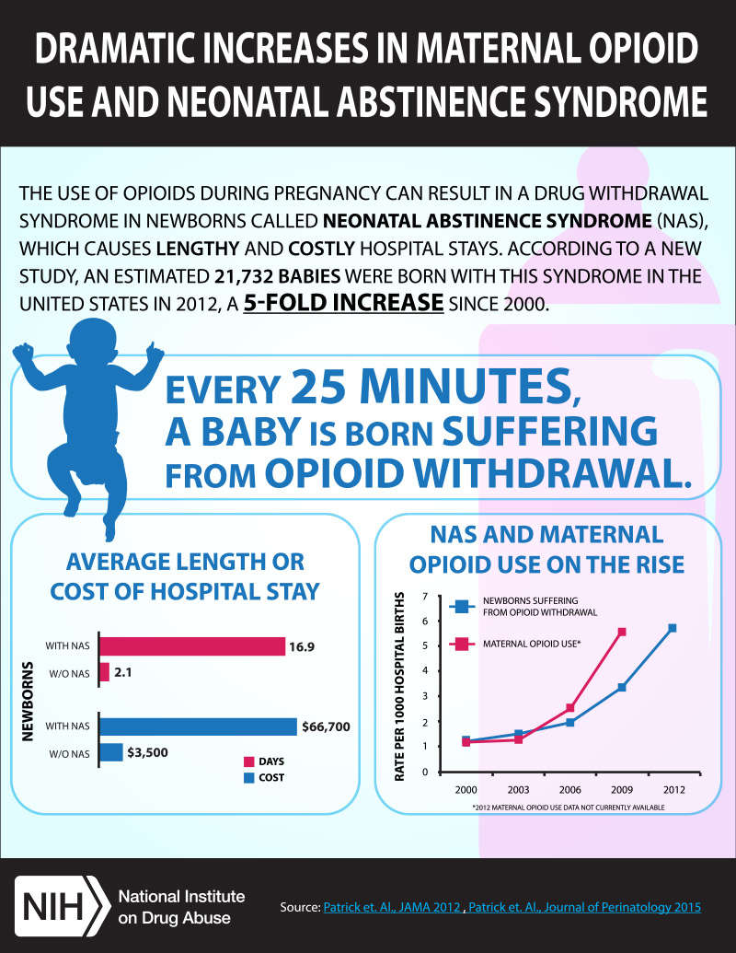
Neonatal Abstinence Syndrome (NAS) is a consequence of the abrupt discontinuation of chronic fetal exposure to drugs (illicit and prescribed) that were used during pregnancy. While non-opioids can cause NAS, opioid abuse has become a top public health concern due to the increased incidence in the past 9 years. The number of delivering mothers using or dependent on opiates rose nearly 5-fold from 2000 to 2009 in the U.S. There was also a 5-fold increase in the proportion of babies born with NAS from 2000 to 2012 in the U.S. and a 50% increase in the incidence of NAS in WA state between 1999-2013. In 2012, newborns with NAS were hospitalized 16.9 days on average (compared to 2.1. days for other newborns), costing hospitals an estimated $1.5 billion.
NAS often results in central nervous system, respiratory, gastrointestinal, vasomotor, and metabolic disruptions.
Clinical Presentation of NAS
- Irritability  - Tremors  - Jitteriness  - Exaggerated Moro reflex  - Hypertonia  - Seizures (rare, 2-11% of neonates) | - Excessive high pitched crying  - Sleep disturbances  - Diarrhea  - Vomiting  - Feeding difficulties | - Poor weight gain  - Hyperphasia  - Sneezing  - Yawning  - Sweating  - Hyperthermia

Evidence-Based Management: Eating, Sleeping, Consoling (ESC) Method for NAS
At Yale New Haven Children’s Hospital, Dr. Matthew Grossman and a multidisciplinary team integrated nonpharmacologic interventions combined with evaluations of the functional well-being of infants with NAS. Additionally, there was a focus on the importance of parent participation being integral to the care. They developed and used their own assessment which focused on 3 simple parameters: the infant’s ability to eat, to sleep, and to be consoled. If the infant was able to E) breastfeed effectively or to take ≥1 oz. from a bottle per feed, S) to sleep undisturbed for ≥1 hour, and, C) be consoled within 10 minutes when crying, then morphine was neither started nor increased regardless of other signs of withdrawal. If the infant did not meet ESC criteria, staff first attempted to maximize nonpharmacologic interventions. If these attempts were unsuccessful, morphine was initiated or increased. As a result of their ESC method, they reduced their average length of stay from 22.4 days to 5.9 days, decreased morphine use from 98% to 14%, and cut cost of hospitalization from $44,824 to $10,289.
What About Breastfeeding?
The American Academy of Pediatrics removed the restrictions on breastfeeding for mothers on any dosage of methadone. Breastmilk contains only minimal quantities of methadone and buprenorphine. (Kocherlakota, 2014)
Benefits:  - Enhances mother-infant bonding  - Encourages active maternal participation in her infant’s care. | Contraindications:  - Mother is taking illicit drugs and not in recovery  - Mother has polydrug abuse  - Mother is infected with HIV
Long Term Management Considerations
There is limited information on long term outcomes in this population. It has been difficult to study this population due to psychosocial issues, mistrust of healthcare professionals, family instability, out of home placements, and poverty. Mothers of infants with NAS often have a complex history of having experienced trauma and/or abuse. Reducing the stigma for these mothers increases the quality of the care for the child.
Infants and children with a history of NAS are at increased risk for motor deficits, cognitive delays, hyperactivity, impulsivity, attention deficit, behavior problems, vision issues, and suboptimal growth. Primary care providers should closely monitor the development of patients with a history of NAS and have a low threshold for referring to a neurodevelopmental specialist. A referral for ophthalmologic assessment should also be considered to identify strabismus, nystagmus, refractive errors or other visual deficits. Growth and nutrition should be followed to identify failure to thrive or short stature.

Special Needs Information and Resources:
(3)
(4)
(5)
Parent-Child Assistance Program (PCAP) | http://depts.washington.edu/pcapuw/
WA State Health Care Authority First Steps Program | https://www.hca.wa.gov/health-care-services-supports/apple-health-medicaid-coverage/first-steps-maternity-and-infant-care
WithinReach Family Health Hotline and Website | Phone number: 1-800-322-2588, 1-800-833-6388 TTD  Website: www.ParentHelp123.org
Early Support for Infants and Toddlers (ESIT) Program | https://www.dcyf.wa.gov/services/child-development-supports/esit  Phone number: 360-725-3500
Providence Drug Exposed Newborns: Neonatal Abstinence Syndrome Course | https://washington.providence.org/events/ewa/professional-education/neonatal-abstinence-syndrome
Substance Abuse & Mental Health Services Administration (SAMHSA) Buprenorphine Treatment Practitioner Locator | https://www.samhsa.gov/medication-assisted-treatment/physician-program-data/treatment-physician-locator?field_bup_physician_us_state_value=WA
SAMHSA Clinical Guidance for Treating Pregnant and Parenting Women With Opioid Use Disorder and Their Infants | https://store.samhsa.gov/product/Clinical-Guidance-for-Treating-Pregnant-and-Parenting-Women-With-Opioid-Use-Disorder-and-Their-Infants/SMA18-5054
Partnership for Drug-Free Kids and The Medicine Abuse Project – Pregnancy & Opioids: What families need to know about opioid misuse and treatment during pregnancy | https://drugfree.org/download/pregnancy-opioids/
Infants with Prenatal Substance Exposure: Yale New Haven Children's Hospital's Approach | https://www.youtube.com/watch?v=7epcyi2mafY
Eating, Sleeping, Consoling (ESC) NAS Care Tool Instructional Manual | http://files.constantcontact.com/dfa00fff501/ce6dfaf8-dc7c-4999-bfb2-fca3ac875c86.pdf
Sachs, Hari Cheryl. (2013). The transfer of drugs and therapeutics into human breast milk: An update on selected topics. Pediatrics, 132(3), E796-809. | http://pediatrics.aappublications.org/content/132/3/e796.full

Kocherlakota, P. (2014). Neonatal abstinence syndrome. Pediatrics, 134(2), E547-61.
National Institute on Drug Abuse. Dramatic Increases in Maternal Opioid Use and Neonatal Abstinence Syndrome.
Ko, J., Patrick, S., Tong, V., Patel, R., Lind, J., & Barfield, W. (2016). Incidence of Neonatal Abstinence Syndrome - 28 States, 1999-2013. MMWR. Morbidity and Mortality Weekly Report, 65(31), 799-802.
Grossman, M., Berkwitt, A., Osborn, R., Xu, Y., Esserman, D., Shapiro, E., & Bizzarro, M. (2017). An Initiative to Improve the Quality of Care of Infants With Neonatal Abstinence Syndrome. Pediatrics, 139(6)
Maguire, D. J., Taylor, S. M., Armstrong, K. S., Shaffer-Hudkins, E., Germain, A., Brooks, S., . . . Clark, L. (2016). Long-term outcomes of infants with neonatal abstinence syndrome. Neonatal Network, 35(5), 277-286.
Buck, T. Maternal Impact from the Opioid Epidemic Presentation, WA State DOH [pdf document].

