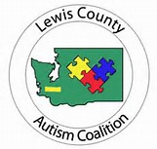

School Medical Autism Review Team (SMART)
Final Report

TO: Special Education Director/Building Administrator
District:
RE: SMART Team Final Report
Date:

Name:_______________________________________ Birthdate:_____________________

The above named student has been reviewed by the medical staff from the School Medical Autism Review Team (SMART) and has resulted in the following conclusions:

____ The student has been evaluated and it has been concluded that he/she meets the diagnostic criteria for autism.

____ The student has been evaluated and it has been concluded that he/she does not meet the diagnostic criteria for Autism.

____ Other:

If you have any questions or concerns please contact the School Medical Autism Team Coordinator at 360-736-6778 or fax questions to 360-736-6552.

