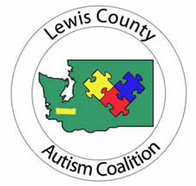

Dear Parent or Guardian,

Your child has been referred to the School Medical Autism Review Team due to concerns of possible Autism Spectrum Disorder (ASD). Enclosed is a packet of information and forms that are needed to further address this issue. Please read this material and follow all instructions so we can be of utmost help to you and your child.

Patients needing a first evaluation for possible ASD.
Our ASD screening process consists of gathering all relevant information concerning your child’s medical, academic, family, and social history.

- Parents/Caregivers, please complete and return to our office the following forms (enclosed)
- Authorization for Release of Records
- SMART Demographics Form
- SMART Tool

- Give a SMART Tool to anyone familiar with your child such as current teacher, SLP, OT, and/or Daycare provider.
- It is your responsibility to ensure the school/providers return these forms to you prior to submitting the package for the SMART team to review.

- Provide our office with copies (no originals please) of:
- Report Cards –past 2 years.
- Reports of any testing done by school psychologists, occupational, language, or physical therapists, Child find, development screening, or school district required testing.
- Copies of 504 plan or IEP’s if applicable
- Reports of any previous evaluations by physicians, psychologists, or psychiatrists.
(Ask school for copies of these if needed)

Please bring the completed packet to Northwest Pediatric Center, 1911 Cooks Hill Road, Centralia WA 98531. If other arrangements need to be made please call, 360.736.6778. Upon receipt of the information, our SMART team will assess the data.

