(Date)
- County Child Health Notes

Promoting early identification and partnerships between families, primary health care providers & the community.

Distributed by (2)
Contributors: Washington State Department of Health and University of Washington, Center on Human Development & Disability (CHDD)
This issue written by Katherine TeKolste, MD, developmental pediatrician at CHDD, with contributions from the work of the Weaving Bright Futures program at the Spokane Regional Health District. Child Health Notes provide physicians, nurse practitioners, primary health care providers, public health centers and community partners with current information regarding identification and management of special health issues for children.
ADVERSE CHILDHOOD EXPERIENCES (ACEs)
ACEs are significant incidents during childhood which can result in harm to social, cognitive and emotional functioning. Resulting changes in brain development can affect a child’s learning ability and social skills, as well as impact long-term adult health outcomes and quality of life. Research at the Centers for Disease Control (CDC) finds, worst case, that childhood trauma can take as many as 20 years off life expectancy. The CDC views ACEs as one of the major health issues of the 21st century. While not guaranteeing bad outcomes, ACEs increase the odds. And they are largely preventable!

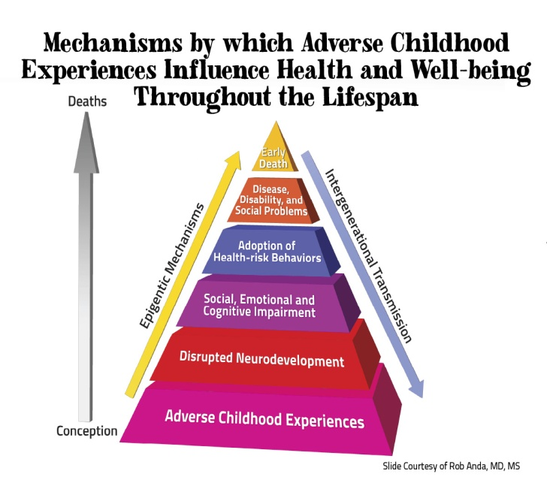 |  | The ACEs Study: Drs. Felliti and Anda, Co-PIs  An ongoing collaboration of the CDC and Kaiser Permanente  The ACES Study is one of the largest investigations ever conducted to assess associations between childhood stressors and well-being later in life. Participants provided detailed information about childhood experiences of abuse, neglect and family dysfunction by completing a questionnaire at a routine health examination. Over 17,000 members of the Kaiser Health Plan in San Diego County, CA, at an average age of 57 years, participated in the initial phase from 1995 to 1997 and continue to be tracked. This work helped build a new understanding of the cumulative effect of adverse experiences on human development and health. The likelihood of risky behaviors and/or poor health outcomes increases as the number of ACEs increases. Although not every adult with a history of ACEs will experience health problems, many will and some will have serious difficulties.
ACEs, Related Stressors and Developmental Delay
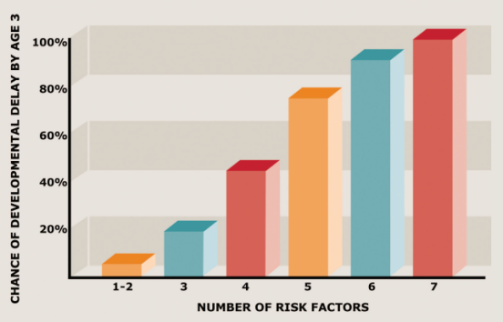 | When children, birth to 36 months of age investigated by the child welfare system due to an exposure to maltreatment, are grouped according to the number of exposures to additional risk factors, one sees an increase in the percentage of children demonstrating developmental delay by age 3 years. There is a cumulative effect of multiple risk factors. Reduction of these risk factors would be anticipated to positively affect child outcomes. Additional adverse risk factors include exposures such as low income status, teen and/or single parent household, low caregiver education, four or more children in the home, and minority status.
Barth, R. P., et al. (2008). Developmental status and early intervention service needs of maltreated children. Washington, DC: U.S. Department of Health and Human Services, Office of the Assistant Secretary for Planning and Evaluation. http://aspe.hhs.gov/hsp/08/devneeds/ch2.htm#B (accessed 11/12/14)

Key Findings: ACEs are strong predictors of health risks & disease in adolescence and beyond
Adverse Childhood Experiences  Are Common*  Household dysfunction:  Substance abuse 27%  Parental sep/divorce 23%  Mental illness 17%  Battered mother 13%  Criminal behavior 6%  Abuse  Psychological 11%  Physical 28%  Sexual 21%  Neglect  Emotional 15%  Physical 10%  *from the original ACEs Study | ACEs Increase Risk For:
 | - Ischemic heart disease  - Cancer  - Chronic lung disease, smoking  - Sexually-transmitted diseases  - Liver disease  - Autoimmune disease  - Skeletal fractures  - Multiple medication use  - Depression and/or anxiety  - PTSD  - Sleep and memory disturbances  - Poor anger control  - Suicide | - Learning disability and/or attention problems  - Poor social skills, family relationships  - Teen/unintended pregnancy  - Absenteeism, impaired school or job performance, dropping out  - Addiction – alcohol, illicit drugs  - Poor self-assessed health or quality of life  - ….And more

ACEs rarely occur in isolation – but rather come in groups and have a cumulative stressor effect. Of persons reporting at least one ACE, 87% reported at least one other ACE. 70% reported 2 or more others and more than half had 3 or more additional ACEs!

Creating Resilience
As compelling as the predictive power of ACEs is, many people do well despite exposure to adversity. As articulated by former president of the American Academy of Pediatrics, Dr. Robert Block, “Rather than saying to parents, ‘You have a problem’, we can say, ‘There are some things going on in your life that are having a tremendous effect on you and your child. Let’s see if we can figure out a way to help and make that situation better.”  We can help children by:  - Gaining an understanding of ACEs in their life  - Creating environments where they are safe, emotionally and physically  - Helping them identify feelings and control emotions  - Creating protective factors at home, in schools and in communities | 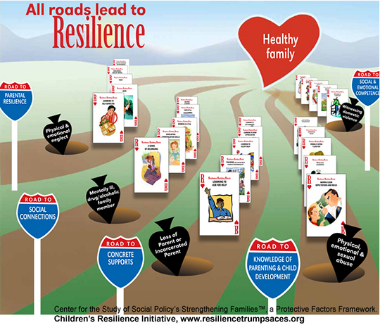
Protective Factors:  - Parental resilience and supportive relationships  - Nurturing relationships with caring adults  - Supportive social connections and peer relationships  - Concrete supports for basic needs (food, housing, health care, etc.)  - Knowledge of parenting and child development  - Social emotional competence |  | For a larger view of Resilience image above click here.
For More Information
A few of the efforts in Washington State
- ACEs Learning Institute at the Foundation for Healthy Generations
http://www.healthygen.org/what-we-do/aces-learning-institute
- Spokane’s trauma-informed schools http://acestoohigh.com/2013/08/20/spokaneschools/
- Children’s Resilience Initiative (Walla Walla, WA) www.resiliencetrumpsaces.org
- Local Public Health efforts http://www.nwcphp.org/training/opportunities/webinars/adverse-childhood-experiences-and-public-health-practice
- Report on public health and social burden of ACES on population scale
    - http://resiliencetrumpsaces.org/docs/ACEs_in_Washington_2009_BRFSS_Final_Report_7_7_2010.pdf
American Academy of Pediatrics
  - Addressing ACEs and Other Types of Trauma in the Primary Care Setting -
http://www.aap.org/en-us/Documents/ttb_addressing_aces.pdf
  - The Resilience Project: Stopping Toxic Stress http://www.aap.org/theresilienceproject
    - Tools to identify CEV (Children’s Exposure to Violence)
Additional Resources
- ACEsConnection.com – the companion social network to ACEsTooHigh.com. Great resources and news stories about ACEs and trauma-informed care from across the US, including sections for WA and for pediatric health providers.
- The Adverse Childhood Experiences Study - http://www.acestudy.org/survey
- The Center for Disease Control and Prevention - http://www.cdc.gov/violenceprevention/acestudy/

(3) County Special Needs Information and Referral Resources
- For children birth to age 18: | Contact: (4)
- For children under age 3: | Contact: (5)
- For children age 3 and older: | Contact: Local school district (6)
- Family Support | Contact: (7)
- WithinReach Family Health Hotline | 1-800-322-2588, 1-800-833-6388 TTD  www.parenthelp123.org/

