Summer /Fall 2016 County Child Health Notes

Promoting early identification and partnerships between families, primary health care providers & the community.

Distributed by: Kitsap County Medical Home Leadership Network
Contributors: Washington State Department of Health and University of Washington, Center on Human Development & Disability (CHDD), Kitsap Strong
This issue written by Katherine TeKolste, MD, developmental pediatrician at CHDD, with contributions from the work of the Weaving Bright Futures program at the Spokane Regional Health District. Child Health Notes provide physicians, nurse practitioners, primary health care providers, public health centers and community partners with current information regarding identification and management of special health issues for children.
ADVERSE CHILDHOOD EXPERIENCES (ACEs)
The ACE Study confirms, with scientific evidence, that adversity during development increases the risk of physical, mental, and behavioral problems later in life. The ACE Study and subsequent research indicate that ACEs are the leading cause of health and social problems in our nation – the most powerful determinant of the public’s health.

Brain development is experience-dependent and sequential. Repeated exposure to life events that cause our brains to release stress chemicals, like cortisol, can become “toxic” to our developing brain cells. Toxic stress can effect brain interaction with body systems and lead to disease, disability, and social/relationship problems throughout the life course. But childhood times are also windows of opportunity for building resilience – the developing brain is sensitive to all kinds of experience, “toxic” or positive! (Source: http://www.aceinterface.com/)
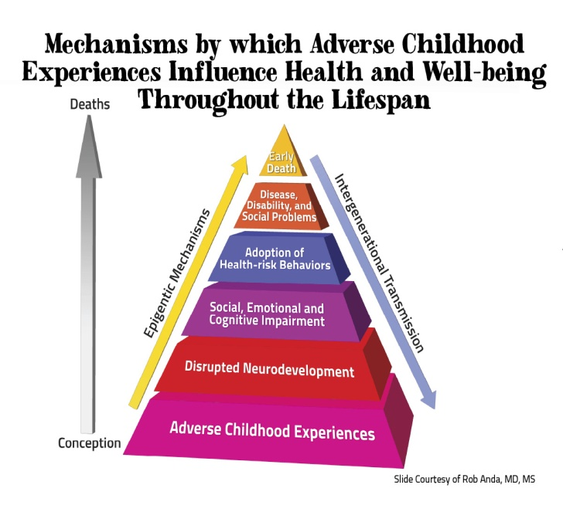 |  | The ACEs Study: Drs. Felliti and Anda  An ongoing collaboration of the CDC and Kaiser Permanente  The ACES Study is the largest of its kind, with over 17,000 participants from the Kaiser Health Plan in San Diego, CA. Participants provided detailed information about childhood experiences of abuse, neglect, and family dysfunction. The ACE Study considered 10 categories of childhood adversity, and the findings include:  - ACEs are common across all categories.  - ACEs are interrelated – 87% with 1 ACE have another.  - ACE accumulation is stored in our bodies, leading to mental, physical, & behavioral health problems throughout our life course.  - Preventing ACEs for the next generation can have a profound impact on the prevalence of most major public health issues in our community, from homelessness, suicide, depression, & drug use to COPD, heart disease, & liver disease!
ACEs, Related Stressors, and Developmental Delay
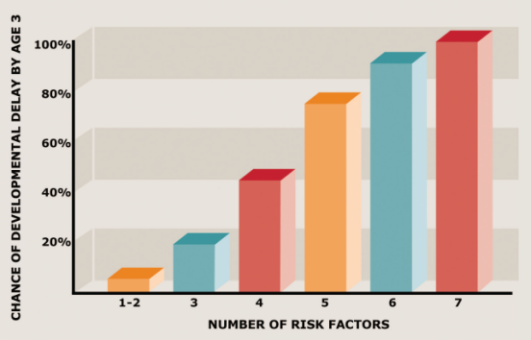 | Brain research tells us the amount of maltreatment (risk factors) we experience during the first 3 years of life, things like - physical, emotional and sexual abuse, neglect, witnessing domestic violence, divorce or abandonment, growing up in a home with a caregiver who has mental health or substance abuse issues, homelessness and poverty - can have profound impacts on how our brain processes certain information. Maltreatment can effect our brain’s ability to focus or pay attention, how we understand social cues and language, our ability to regulate our hormones, mood, and even our heartbeat.
Barth, R. P., et al. (2008). Developmental status and early intervention service needs of maltreated children. Washington, DC: U.S. Department of Health and Human Services, Office of the Assistant Secretary for Planning and Evaluation. http://aspe.hhs.gov/hsp/08/devneeds/ch2.htm#B (accessed 11/12/14);
Key Findings: ACEs are strong predictors of health risks & disease in adolescence and beyond
Adverse Childhood Experiences  Are Common*  Household dysfunction:  Substance abuse 27%  Parental sep/divorce 23%  Mental illness 17%  Battered mother 13%  Incarcerated family member 6%  Abuse  Psychological 11%  Physical 28%  Sexual 21%  Neglect  Emotional 15%  Physical 10%  *from the original ACEs Study | ACEs Increase Risk For:
 | - Absenteeism, impaired school or job performance, dropping out  - Addiction – alcohol, illicit drugs  - Autoimmune disease  - Cancer  - Chronic lung disease, smoking  - Depression and/or anxiety  - Ischemic heart disease  - Learning disability and/or attention problems  - Liver disease  - Multiple medication use | - Poor anger control  - Poor self-assessed health or quality of life  - Poor social skills and poor family relationships  - PTSD  - Sexually-transmitted diseases  - Skeletal fractures  - Sleep and memory disturbances  - Suicide  - Teen/unintended pregnancy  - ….And more

ACEs rarely occur in isolation – but rather come in groups and have a cumulative stressor effect. Of persons reporting at least one ACE, 87% reported at least one other ACE. 70% reported 2 or more others and more than half had 3 or more additional ACEs!

Creating Resilience
As compelling as the predictive power of ACEs is, many people do well despite exposure to adversity. As articulated by former president of the American Academy of Pediatrics, Dr. Robert Block, “Rather than saying to parents, ‘You have a problem’, we can say, ‘There are some things going on in your life that are having a tremendous effect on you and your child. Let’s see if we can figure out a way to help and make that situation better.”  We can help children by:  - Gaining an understanding of ACEs in their life  - Creating environments where they are safe, emotionally and physically  - Helping them identify feelings and control emotions  - Creating protective factors at home, in schools and in communities | 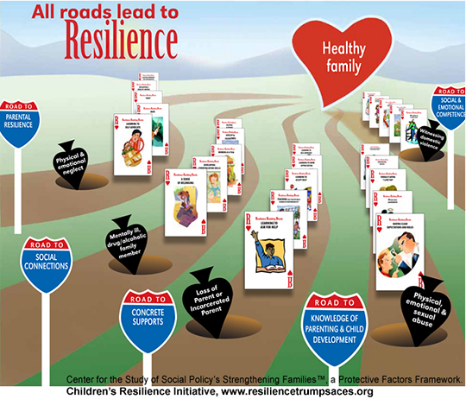
Protective Factors:
- Parental resilience and supportive relationships
- Nurturing relationships with caring adults
- Supportive social connections and peer relationships
- Concrete supports for basic needs (food, housing, health care, etc.)
- Knowledge of parenting and child development
- Social emotional competence
For More Information
A few of the efforts in Washington State
- ACEs Learning Institute at the Foundation for Healthy Generations
http://www.healthygen.org/what-we-do/aces-learning-institute
- Spokane’s trauma-informed schools http://acestoohigh.com/2013/08/20/spokaneschools/
- Children’s Resilience Initiative (Walla Walla, WA) www.resiliencetrumpsaces.org
- Local Public Health efforts http://www.nwcphp.org/training/opportunities/webinars/adverse-childhood-experiences-and-public-health-practice
- Report on public health and social burden of ACES on population scale
    - http://resiliencetrumpsaces.org/docs/ACEs_in_Washington_2009_BRFSS_Final_Report_7_7_2010.pdf
American Academy of Pediatrics
  - Addressing ACEs and Other Types of Trauma in the Primary Care Setting -
http://www.aap.org/en-us/Documents/ttb_addressing_aces.pdf
  - The Resilience Project: Stopping Toxic Stress http://www.aap.org/theresilienceproject
    - Tools to identify CEV (Children’s Exposure to Violence)
Additional Resources
- ACEsConnection.com – the companion social network to ACEsTooHigh.com. Great resources and news stories about ACEs and trauma-informed care from across the US, including sections for WA and for pediatric health providers.
- The Adverse Childhood Experiences Study - http://www.acestudy.org/survey
- The Center for Disease Control and Prevention - http://www.cdc.gov/violenceprevention/acestudy/

(3) County Special Needs Information and Referral Resources
- For children birth to age 18: | Kody Russell, MSW  Kitsap Strong: ACEs & Resiliency Project Director  206-949-7018 Cell kody.russell@kitsapstrong.org  Kitsap Public Health District – Children with Special Health Care Needs Program  360-337-4821
- Family Support | Kitsap Mental Health  www.kitsapmentalhealth.org
- WithinReach Family Health Hotline | 1-800-322-2588, 1-800-833-6388 TTD  www.parenthelp123.org/

