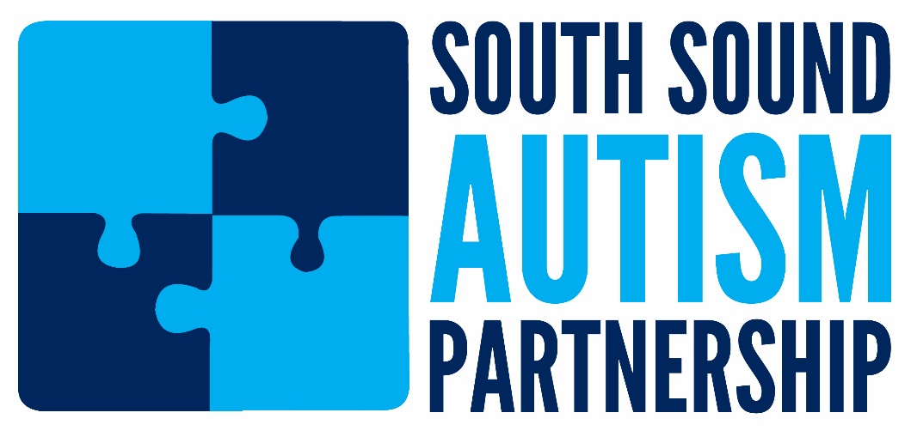

Our mission: to promote access to services, improve the effectiveness of service delivery in the South Puget Sound, and educate the public about Autism Spectrum Disorders (ASD).

Meetings every 2nd Friday of the month from 9:30-11:00am on UW-Tacoma campus Cherry Parkes Bldg Room 338

Our Contact Info:
Website: www.southsoundautism.org/
Facebook: www.facebook.com/SouthSoundAutism
Email Listserv = Patti Matestic: matestic@uw.edu

