(Date)
- County Child Health Notes

Promoting early identification and partnerships between families, primary health care providers & the community.

This newsletter provides physicians, nurse practitioners, primary health care providers, public health centers and community partners with current information regarding identification and management of special health issues for children. This issue written by Gwen Glew, MD, MPH, reviewed by Kathy TeKolste, MD, developmental pediatricians, Kate Orville, MPH, UW Center on Human Development and Disability, and Louise Gane, M.S., genetics counselor of the M.I.N.D. Institute, University of California Davis. Distributed by the Washington State Department of Health and (2).

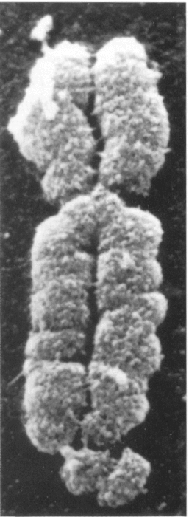 | Testing for Fragile X Syndrome and Related Disorders  (FXTAS, FX-POI)  Fragile X is the most common inherited cause of intellectual disability. It is standard of care to test for fragile X in all children with developmental delay or autism. Fragile X can be the underlying cause of autism spectrum disorders. Because fragile X syndrome and its carrier conditions are so common, many specific treatments are being developed and tested for this population. Many drugs scientists hope will be useful for all children with intellectual disability and autism are being tried first in individuals with fragile X because the pathophysiology of fragile X is known and the patient population is relatively large.

Remember to test for fragile X if you encounter someone with:
- A family history of the following: fragile X, carrier of fragile X (the premutation), FXTAS (fragile X tremor ataxia syndrome), intellectual disability, learning disability, autism spectrum disorder of unknown cause, or infertility, or
- Any symptoms suggestive of fragile X or a fragile X carrier disorder (listed immediately below).
Specific Indications for Fragile X Testing (any one of these can be a reason to test)
- Intellectual disability
- Developmental delay
- Speech and language delay
- Autism spectrum disorder without an already-identified genetic cause (about 60% of those with fragile X have autism)
- Infertility (this can be a sign of fragile X-premature ovarian insufficiency (FX-POI)
- Irregular menses - this can be a sign of fragile X-premature ovarian insufficiency (FX-POI) which occurs in a subset of female carriers
- Adults over 50 with intention tremor, ataxia, memory loss, cognitive decline, and personality change - this can be a sign of fragile X tremor/ataxia syndrome (FXTAS) which is seen in a subset of carriers
- Any individual who requests fragile X testing

Lab Tests for Fragile X
                - To test for fragile X, it is ideal to order two tests. In some labs, this is done automatically when “fragile X testing” is requested. Complete FMRI DNA testing involves obtaining two complementary lab procedures done on the same sample of blood:
- PCR (polymerase chain reaction) determines whether the number of CGG repeats is in the fragile X, premutation, or normal range at the FMR1 gene. Over 200 repeats is fragile X syndrome, 50-200 repeats is the premutation (carrier status), and 0-49 is normal.
- Southern blot determines the number of repeats in the full mutation, whether the gene has been methylated, and presence of mosaicism. Fully methylated individuals are usually more severely affected as methylation inactivates genes. The gene must be active for the individual to be normal. Mosaics tend to be less affected.

REMEMBER: Chromosomal arrays and karyotypes will NOT detect fragile X mutations.

Logistics of Testing
                - The two blood tests used together usually range from $300 to $600. Results are often available in 2 to 3 weeks. If the testing comes back positive, refer to a geneticist, genetics counselor, or fragile X clinic. It is often helpful to refer the family to the National Fragile X Foundation which provides extensive educational resources for families and professionals.

Some providers prefer to refer families for genetic counseling prior to testing. The genetics counselor can coordinate testing and communicate the results back to the provider and family. If there is a prohibitively long wait for genetics counseling or if it is not available locally, an alternative option is to use informedDNA.com, to obtain telephone genetics counseling services. This service typically has no wait.

Why Test?
                - Many providers question the wisdom of genetic testing because, at present, there is no way to “fix” the gene mutation responsible for fragile X. However, there are many specific treatments, therapies, strategies, and educational resources available for people with fragile X and related disorders that can improve lives and the lives of family members. In addition, for extended family members, there are serious fertility implications that may impact reproductive planning and progressive neurological problems in carriers over age 50 that make knowledge of the disorder key. Making the proper diagnosis rules out other diagnoses and decreases the risk of medical errors and unnecessary testing. Diagnosis is key to providing specific treatment recommendations including counseling regarding future reproductive options.

References
                - National Fragile X Foundation website: http://www.fragilex.org
- Fragile X Association of Washington State: http://www.wafragilex.org/
- The premiere textbook on fragile X syndrome: Randi and Paul Hagerman. 2002. Fragile X Syndrome: Diagnosis, Treatment, and Research. Baltimore and London: Johns Hopkins University Press.

Local Clinical Resources
- Seattle Children’s Hospital Autism Center. The Seattle Children’s Hospital Autism Center accepts patients with fragile X whether or not they have autism as long as a referral from the primary care provider has been obtained. Call 206-987-8080 with questions.
- University of Washington. Center on Human Development and Disability. Neurologist and geneticist, Dr. Fuki Hisama, tests and treats adults for fragile X and associated disorders in the Seattle area. Primary care referral is required. Call 206-598-4030 for more information and appointments.

County Specific Needs Information and Referral Resources
- For children birth to age 18: |  | Contact: (4)
- For children under age 3: |  | Contact: (5)
- For children age 3 and older: |  | Contact: Local school district (6)
- Family Support |  | Contact: (7)

